Machine Learning 1

Thursday, June 27

SiiM 2019

2019

Timothy Kline

Steve Langer

Keyvan Farahani

Peter Chang

# Instructions for obtaining a MD.ai token

## Overview

Some of the data sets needed by the Jupyter notebooks pull on datasets at MD.ai. To access them requires using a token. To get the token we need to do the following [use Chrome browser for best results]

## Setup google account

In order to work with the learning lab lessons you will first need to obtain a google account if you do not already have one. If you already have an account (e.g., a google email) please go to the next section for ‘**Create an mdai client**’ token.

To register a new google account, please go to:

<https://accounts.google.com/signup/>

And create your google account. An account is necessary to access the data available through Google Colab. Alternatively, you can access the data using a GitHub account as well.

## Create an mdai client token

To setup up your access token for the mdai client, go to:

<https://public.md.ai>

Here you can obtain your user access token. Select the drop bar at the left of the screen:

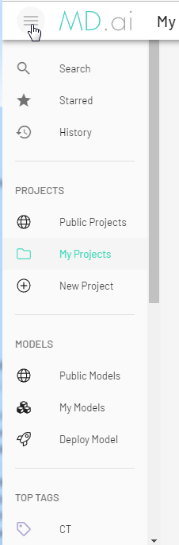

Scroll down to the bottom and select the ‘User Settings’ tab:

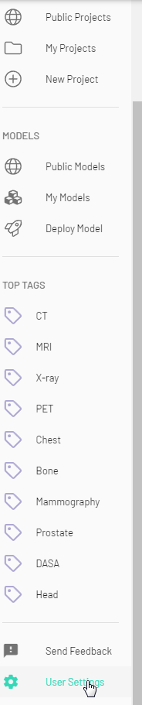

[Note a first you will see nothing except “You must be logged in to view””.

Press Login in the upper right and this is where you will be prompted for your Google account

Then you will see a screen that says “You have not been added to any projects”

IN the upper right you will see your Google acct. Avatar.

Select the Avatar/User setting

Then you will see a popup box that says “Account or Personal Access Tokens” ]. Press “Personal Access Token”

From there you can get your Personal Access Token by selecting and generating a new token. This token is used when querying for the datasets that are used in the Learning Lab notebooks.

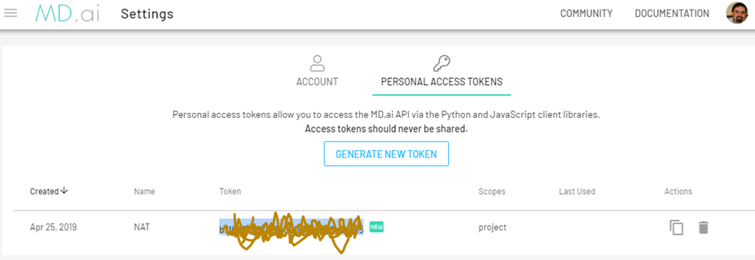

Note that you should never share your public access token.

## Accessing Data

The jupyter notebooks for the learning labs takes advantage of two different publicly available datasets. You will need to enter your token value in the appropriate location within each notebook. For example:



Now you can download data directly and work on the supplied notebooks. For example, data from the lung opacity dataset can be loaded as:

